BSC - Controls - CRS
  - The customer requirements specification for the controls of the new BSC
Version 1.0 / 12 February 2025

Introduction
With this document we want to determine the CRS (customer requirement specifications) for the controls of the new BSC controller. The BSC will be designed to control the climate in one cattle barn, and will provide controls for up to 8 areas within a building. To control the climate in separate buildings separate BSC controllers are required.
DeLaval is planning to use a new commercial name for the BSC. Since that name is not yet known we will keep using the name BSC. In this document we will refer to the current controller on fusion platform as BSC2 and to the new controller on the Halo 7” platform as BSC3.

Platform
The base of the product will be the hard- and software of the Hotraco Halo 7” platform. For the design of the software we try to stay as close as possible to our own products to keep the effort of development, maintenance and future platform updates low.

IO-boards
For the IO we will use the CAN-IO-12-17P board this has following features:
- 8 analog inputs that can measure temperatures, 0-5V and 0-20mA signals.
- 4 digital inputs that support level and counter functionality
- 4 analog outputs that can provide a 0-10V signal
- 12 digital outputs, of which are 8 solid state outputs (24Vdc) and 4 relay contacts (potential free).
- 1 alarm contact
- 1 RS485 / Modbus interface (not yet implemented in software)
Since the controller and the IO-board are connected via our CAN-LOCAL bus it is easy to connect extra CAN-IO boards when the number of IO isn’t sufficient. Besides the new CAN-IO-12-17P we will also support the existing boards that DeLaval used in combination with circulation fans and cow cooling, namely:
- CAN-IO-08-11
- CAN-IO-06-14
- CAN-IO-12-06

Network
Eventually DeLaval wants to be able to exchange data between the BSC3 and DLIB, in this phase we will only prepare the possibility to establish the ethernet connection between the BSC3 and DLIB. Exchanging actual data will be part of a next phase.

Default configurations
In order to reduce complexity for the installer, DeLaval wants to be able to use a number of default configurations. Our platform provides the possibility to store and restore backups of options and settings on an external data-storage like a USB-stick. We can use this to realize the desired functionality, by providing the BSC3 with a USB stick with the default settings on it. By using the USB-stick instead of hardcoded defaults we are able to adjust or add defaults without software development.

Modules
Our platform provides the possibility to lock / unlock software modules with a code based on the serial number so we are able to sell the same controller for different prices based on the available modules. Regarding to future expansions of the BCS3 software we recommend to make a module for climate controls like circulation fans and cow cooling. For now we will always activate climate, but in the future it gives you the possibility sell a BSC3 with for example manure handling functionality, without the climate functionality.

Controls
Starting point of the requirements for the controls is the functionality of the mix vent and cow cooling of the BSC2.

Measurements

Temperature
The BSC2 uses our 2-wire KTY sensors, since these sensors are obsolete, we switch over to the 3-wire PT1000 sensor which is the standard for almost all our other products. For temperature measurement it should be possible to connect one or more of these temperature sensors. These sensors can measure temperatures from -50.0 to 102.0°C, if the measured value is outside this range we consider the sensor as defective.

Humidity
For humidity measurement one or more RH sensors can be connected. These sensors use an analog input that can measure 0-5V or 0-20mA. In case a 4-20mA sensor is applied the we consider the sensor as defective if the measured value is below 4mA.

THI
When a temperature and humidity sensor are assigned the THI can be calculated. Since temperature and relative humidity have a strong relationship temperature and RH should be measured at the same place.

Alarms
Like the BSC2 the new controller should be able to give alarm based on a too high or low temperature, RH and or THI. These alarms should be optional, in other words these alarms are only available when they are activated by the installer.
Besides the minimum and maximum alarms the controller should also give an alarm when one or more of the sensors doesn’t function well.
We will give the user the possibility to set sensors out of use in case they aren’t functioning well.

Weather station
Regarding to the weather station the BSC2 supported the following items: Outside temperature, Wind speed, Wind direction and up to 2 rain sensors.
Since the BSC3 will not support all the controls that where in the BSC2, the ‘weather station’ of the BSC3 will only support outside temperature (3-wire PT1000) and wind speed (0-5V anemometer).
When there are more BSC3 controllers at one site these BSC’s will be able to exchange weather data via the ethernet backbone.

Sensors per area
Besides the general temperature and humidity sensor assignment there will be a possibility to assign sensors per area. In order to reduce complexity for the installer these assignments will only be shown at a control in case the ‘Number of areas’ is more than one and the option ‘Sensors per area’ is activated.

Mixing ventilation
The mix vent control of the BSC2 combines 2 purposes:
- Controlling exhaust fans:
Exhaust fans extract air from the barn to replace it with fresh outside air.
- Controlling circulation fans:
Circulation fans move the air within a barn to equalize the climate and or create an airflow over the animals.
For BSC3 we will only takeover functionality for the circulation fans. Because the exhaust fans aren’t used anymore, they will not be supported by BSC3.
For circulation fans the BSC3 will provide following functions:
- Temperature or THI control:
The circulation fans can be controlled based on temperature or THI. The fans can either be on/off controlled, with a fixed speed, or proportionally, with a variable speed.
  - For on/off controlled fans we foresee a set value and a hysteresis to prevent excessive switching.
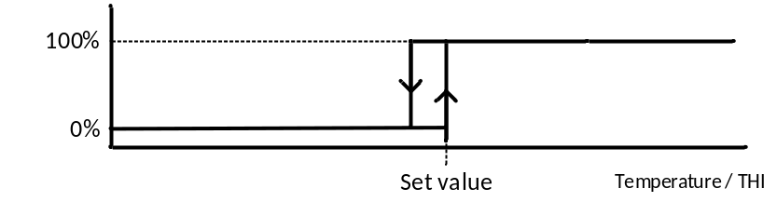
For the proportional controlled fans we foresee a standard P-range control with a set value, minimum, maximum and p-range. Additionally there will be a setting set the point at which the fans are switched off entirely.
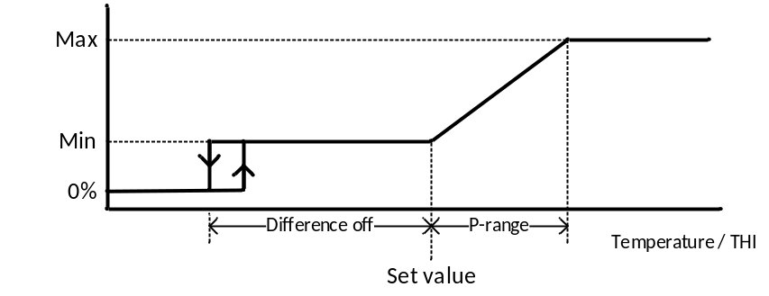
Besides this standard control on temperature or THI there are other factors that determine whether the circulation fans get active, these will be stated below:
- Timer:
A timer can be used to set timeslots within which the fans may be activated.
The circulation fan control has a timer function to set during which timeslots the fans may be active. The timer function will be optional, e.g. the user will only see the regarding settings when the function is activated in the installation menu.
- Windspeed:
When a windspeed sensor is applied we provide the possibility to switch off the fans when the windspeed gets too high.
- Temporary enable:
For the cold period we provide the possibility to switch on the fans during a certain time at a certain level. Time and level will be adjustable. This can be activated on screen and by using a button.

Areas and zones
The circulation fan control of the BSC2 provided only 1 general fan control for the whole barn. Circulation fans that were linked to the cow cooling were controlled by cow cooling control. Since we now want to control all the fans via circulation fan control, circulation fan control also needs areas and zones. This gives us a few advantages:
- Different areas can be used to control different parts of the circulation fans on different sensors.
- For on/off controlled fans the zones can also be used to reduce the inrush current, by switching on zones subsequently with 2 seconds delay.
In order to prevent a shortage of outputs we want to preserve the possibility to use a general analog or digital output.

Cow cooling
Cow cooling consist of 2 parts: valves to spray water over the cows and circulation fans to create an airflow over the cows. The cow cooling control of the BSC2 combines has outputs for spraying and fans. On the BSC3 we will do this in a different way.
Instead of controlling the fans directly we provide a possibility to connect the spray cooling to the circulation fans, in this way we can easily use a part of the fans for ventilation and cooling.
The BSC3 will provide following functions for the spray cooling:
- Temperature or THI control:
The spray cooling can be controlled based on temperature or THI. The cooling starts when measured value exceeds the set value. To prevent excessive switching a hysteresis function is provided, e.g. the cooling stops when the measured value gets below the set value minus the hysteresis.
Besides the set value there are other factors that determine whether the cow cooling gets active, these will be stated below:
- Timer:
The cow cooling has a timer function to set during which timeslots the spraying may be active. The timer function will be optional, e.g. the user will only see the regarding settings when the function is activated in the installation menu.
- Humidity:
When a humidity sensor is applied, spraying can be stopped when the measured RH gets too high.
- Windspeed:
When a windspeed sensor is applied, spraying can be stopped when the windspeed gets too high. This can be used to avoid the water coming down in the cubicles.
- Average night temperature:
It takes a while before heat has a negative effect on the performance of cows. If it’s cold enough during the night there is no need to activate cow cooling during the day. Cow cooling calculates the average night temperature to determine whether cow cooling should be available during the following day. To easily override this condition an extra button can be connected.
- Safety temperature:
When THI control is activated an additional safety value for the temperature can be set. When the actual temperature is below this setpoint the spraying will not run, regardless the average THI. Please note: on the BSC2 this function was only available during the night period.
- Hand-0-Auto setting:
In order to be able to override the normal control there will a Hand-0-Auto setting so the user is able to activate or deactivate the spraying easily.

Valve control
The BSC2 did support 3 modes of valve control, on the BSC3 these 3 modes will also be available:
- Continuous control:
The valves are continuously on when cooling is active.
- Fixed pulse time:
The pulse time for the valves is fixed.
- Variable pulse time:
The pulse time for the valves depends on the difference between the set value and the measured value. As the temperature (or THI) gets higher the temperature is gradually increased from the minimum to the maximum pulse time.
When cow cooling starts, the cows are dry, to ensure a cooling effect at the start, the pulse time for the first 2 pulses is twice the normal pulse time. Since this would only affect the first cows that enter a zone with cow presence detection, this is not applicable when cow presence detection is used.
To be able to log the valve control the duty cycle of the valve outputs is determined per minute.
The BSC2 provides the possibility to shift the water pulses so they are executed subsequently to avoid water shortage. Because this function caused the fans running on low speed for a longer time and it is no longer needed because of cow presence detection, so we leave out this function.

Cow presence detection
To preserve water and energy cow presence detection can be used, so the cow cooling will only be active if there are cows present. The cow presence detection normally exists of light barrier sensors that are mounted on the feeding fence. The sensors are connected to one or more digital inputs so the controller knows at which section of the fence there are cows present.
In addition to the BSC2 we will provide a minimum time setting (in seconds) to prevent the cow cooling from starting when the light barrier is interrupted for a short term, for example by a bird or a farmer passing the feeding fence.

Areas and zones
The BSC2 provides a cow cooling control for 8 areas with up to 4 zones per area. Since the current time based zone control doesn’t match practice and isn’t used anymore it will be discontinued. Instead we will provide the possibility for a zone control based on the cow presence detection. For example when a feeding area has multiple light barrier sensor inputs, the area will be programmed as 1 area with multiple zones, so the whole area has the same settings. (On the BSC2 an area per sensor input was needed.)

Fan control
To avoid the water coming down in the cubicles the circulation fans can be switched off or the fan speed can be reduced during spraying.
Since the airspeed doesn’t drop instantly there will be a delay between reducing airspeed and the start of spraying. Since reducing airspeed is needed only for the areas where spraying is active. Therefore there will be a possibility to link the areas of the cow cooling to certain parts of the circulation fans so only those fans will reduce their speed.

